# freETarget

Application Note: Going Wireless

**SUMMARY**

This application note details the components and configuration needed to implement a wireless connection.

The application

**REQUIRED**

|  |  |  |
| --- | --- | --- |
| Item | Description | Obtained From Amazon or Similar |
| 1 | freETarget V3.0.3or higher | <https://allanbrownatl.files.wordpress.com/2021/09/freetarget-3.0.3.zip> |
| 2 | freETarget firmware 3.4.8 or higher | <https://allanbrownatl.files.wordpress.com/2021/09/freetarget-3.4.8.hex_.zip> |
| 3 | ESP-01 | <https://www.amazon.com/Wireless-Transceiver-Receiver-DC3-0-3-6V-Compatible/dp/B07R4MXPLF/ref=sr_1_12?crid=3V1D0J59OCRTH&dchild=1&keywords=esp-01&qid=1624114287&sprefix=esp-01%2Caps%2C169&sr=8-12> |
| 4 | ESP-01 5Volt Adapter | <https://www.amazon.com/Aideepen-ESP8266-Wireless-Adapter-Compatible/dp/B01M09B43H/ref=sr_1_3?dchild=1&keywords=esp-01+5V&qid=1624114362&sr=8-3> |
| 5 | 2x6 Pin IDC Connector | https://www.digikey.com/en/products/detail/te-connectivity-amp-connectors/3-640441-6/698225 |
| 6 | 24 Gauge Wire |  |

**OPTIONAL**

|  |  |  |
| --- | --- | --- |
| Item | Description | Obtained From |
| 1 | 9 Volt Power Supply | <https://www.amazon.com/iCreatin-Adapter-Arduino-Tbuymax-Positive/dp/B07CR1BY9M/ref=sr_1_5?keywords=arduino+power+supply&qid=1645196707&sr=8-5> |

**INTRODUCTION**

freETarget supports a WiFi connection using the accessory connector and an off-the-shelf ESP-01 Serial WiFi transceiver. Using the ESP-01, freETarget appears as a WiFi hotspot that when a connection is made transmits the score JSON message to the PC program.

Installing the ESP-01 consists of the following steps

* Build the ESP-01 interface
* Attach the ESP-01 to freETarget
* Select the target name
* Power Up
* On the PC choose the freETarget SSID for your target
* Use the bridge application freeTargetWiFi2Com to connect the target to the program

**ASSEMBLING THE WiFi INTERFACE**

**Building the ESP-01 Adapter**

The ESP-01 is a self-contained circuit that operates at 3.3 Volts. freETarget operates at 5.0 Volts, so connecting an ESP-01 directly to the board will damage the ESP-01 circuit. Fortunately, adapter circuits are available that convert the voltage levels. Install the ESP-01 into the adapter as shown in Figure 1.

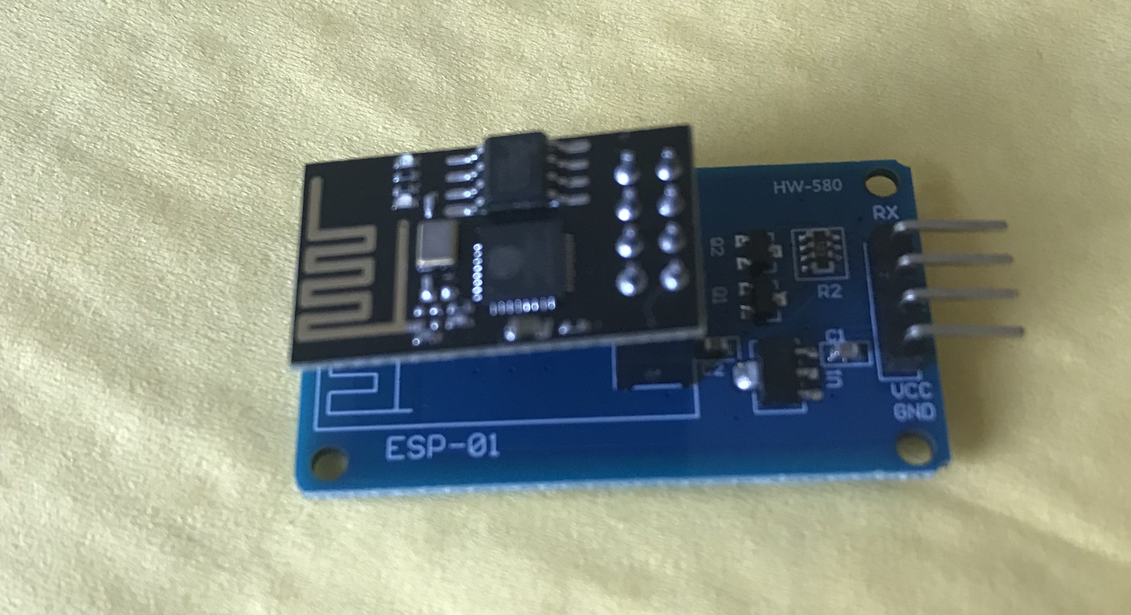

Figure 1: ESP-01 and Adapter Assembly

The ESP-01 and freETarget connect to each other using a short six pin connector illustrated in Figure 2. While the ESP-01 adapter uses four pins and freETarget uses six, for the purposes of convenience two six pin connectors can be used.

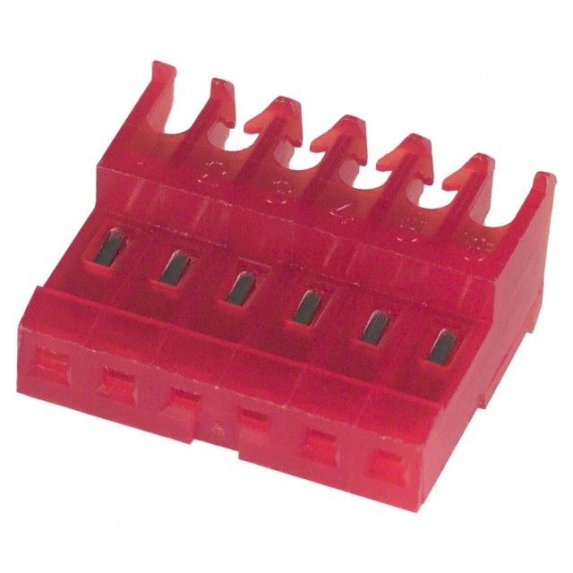

Figure 2: Sample IDC Connector

The wiring for each of the connectors is found in Table 1 and Figure 3

Table 1: WiFI Cable Harness with Colours

|  |  |  |  |  |
| --- | --- | --- | --- | --- |
| freETarget  Connector |  | Description | ESP-01  Connector |  |
| 1 | Red | 5VDC | 2 | Red |
| 2 | White | Auxiliary Transmit Data | 4 | White |
| 3 | Yellow | Auxiliary Receive Data | 3 | Yellow |
| 4 | TBD | Motor Drive (Not Used) |  | TBD |
| 5 |  | Spare (Not Used) |  |  |
| 6 | Black | Ground | 1 | Black |

|  |  |
| --- | --- |
|  |  |
| Figure 3: WiFi Cable on Arduino | WiFi Cable on ESP-01 |

**Connect the ESP-01 to freETarget using the cable harness.**

IMPORTANT

When connecting the cable harness to the ESP-01, ensure that Pin 1 of the connector mates to Pin 1 of the adapter. Pins 5 and 6 will overhang the board and not be connected.

**Naming the Target**

freETarget allows you to assign a name to each target for identification. This name appears in the SSID of the WiFi sources on your computer. If you are using a single lane freETarget, the default name “FET-TARGET” can be used for the SSID.

In larger installations a name can be chosen from Table. Use NAME setting found in the PC program setup tab.

Table 2: freETarget Lane Names

|  |  |
| --- | --- |
| Name ID |  |
| 0 | TARGET |
| 1-10 | Numeric 1-10 |
| 11-18 | Seven Dwarfs  “DOC", "DOPEY", "HAPPY", "GRUMPY", "BASHFUL", "SNEEZEY", "SLEEPY" |
| 19-27 | Eight Reindeer  "RUDOLF", "DONNER", "BLITZEN", "DASHER", "PRANCER", "VIXEN", "COMET", "CUPID", "DUNDER" |
| 28-32 | Norse Gods  "ODIN", "WODEN", "THOR", "BALDAR" |

**Native WiFi Support**

Starting with Version 3.0.3 of the PC program WiFi support is built into the program and can be used in the same manner as the USB Serial Port

Launch the program and under the settings icon (Gear Wheel), General Tab, look for the Communication Protocol selection (Figure 4). Make sure that TCP is selected and that the IP address is as shown.

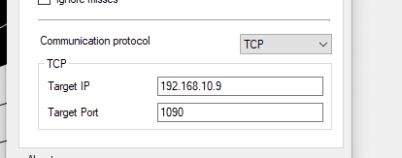

Figure 4: Communication Protocol Selection

Press CONNECT to connect to the freETarget. The program will show the freETarget firmware version. Only 3.4.8 and higher will work correctly.

**TROUBLESHOOTING**

If your freETarget is not working with the PC program, carry out the following checks

* Connect to the freETarget using the conventional COM port.
  + Connect to the board
  + Using the Arduino Button examine the settings
    - Does the string “WiFi”:1 appear?
      * The ESP-01 WiFi adapter is connected and recognized by the Arduino
    - Does the string “WiFI”:0 appear?
      * The ESP=01 WiFi adapter is not connected
      * Verify the cable harness and connections
* Verify that the PC program has the correct connection (TCP) and IP addresses

**SPECIFICATIONS**

When an ESP-01 is attached to freETarget, the firmware will detect the ESP-01 and automatically configure the connection.

**SSID**

The WiFi SSID connection will take on the name of the target, FET-<name>. For example FET-TARGET or FET-RUDOLF.

**freETarget IP Address**

The freETarget IP address is fixed and is 192.168.10.9

**PC IP Address**

The ESP-01 contains a DHCP server and will assign the PC an address of 192.168.10.0

**Server Connection**

The PC acts as a client to freETarget, and connects to freETarget on port 1090